**The Role of Social Media Influencers in Promoting Luxury Ayurvedic Products: A Case Study of Jivisa**

**A Dissertation report submitted to Doon Business School, Dehradun**

**For the partial fulfilment of MBA**

**Submitted to**

**Dr.Himanshu Chauhan**

**Submitted by: PT Manivannan**

**Class: MBA IV-A**

**ERP ID: 0221MBA002**

**Batch 2022-2024**

# 

TO WHOMSOEVER IT MAY CONCERN

# 

# 

This is to certify that P T Manivannan, ERP 0221MBA002, has successfully completed and submitted the dissertation report titled The Role of Social Media Influencers in Promoting Luxury Ayurvedic Products: A Case Study of Jivisa as a requirement for the fulfilment of MBA at Doon Business School, Dehradun.

The dissertation report demonstrates the student's comprehensive understanding, original research, and significant contribution to the field of study. It reflects their dedication, perseverance, and academic excellence.

This report is his original work and has not been submitted to any other institution /University for any type of submission.

Dr. [Himanshu Chauhan](mailto:himanshuchauhan@doonbusinessschool.com)

Associate Professor(Marketing)

Doon Business School

# 

**Table of Contents:**

The Role of Social Media Influencers in Promoting Luxury Ayurvedic Products: A Case Study of Jivisa 5

Role of Influencer Marketing: 8

Why do Customers Trust Influencers? 10

Word of mouth markeign - WOMM vs Influencers Marketing: 12

Literature Review: 13

Influencer Marketing: An Exploratory Study to Identify Antecedents of Consumer Behavior of Millennial 13

CONCEPTUALIZING INFLUENCER MARKETING: A LITERATURE REVIEW ON THE STRATEGIC USE OF SOCIAL MEDIA INFLUENCERS 14

Social Media Marketing Influencer: Literature Review on Promotional Strategies Using the Influence of Social Media Celebrities 15

**About jivisa:** **16**

**Jivisa Products:** **19**

**Partners:** **22**

**Jivisa’s Influencer Marketing Startegy:** **22**

**Jivisa and their Live Topics:** **24**

**Stats Of Jivisa:** **26**

**Influencers:** **32**

**Conclusion:** **32**

**ACKNOWLEDGEMENT**

I am immensely grateful and filled with a sense of accomplishment as I reach this significant milestone in my academic journey. The successful submission of my dissertation would not have been possible without the support, guidance, and encouragement of numerous individuals and institutions, to whom I owe my deepest gratitude.

First and foremost, I extend my heartfelt appreciation to my dissertation advisor, Dr. Himanshu Chauhan, whose expertise, patience, and unwavering support were instrumental in shaping the direction and quality of my research. Their invaluable guidance, insightful feedback, and dedication to my academic growth have been truly inspiring. I am fortunate to have had the privilege of working with such an exceptional mentor.

I would also like to express my gratitude to the faculty members of the Doon Business School for their knowledge-sharing, thought-provoking lectures, and the intellectually stimulating environment they fostered. Their expertise and passion for their respective fields have been instrumental in broadening my horizons and shaping my academic pursuits.

In conclusion, I am truly humbled and grateful for the support and guidance I have received throughout my journey towards the successful submission of my dissertation. This accomplishment is not solely mine but also a result of the collective efforts and contributions of those who have touched my academic life. I am filled with a sense of fulfilment and look forward to the future opportunities that lie ahead.

Thanking You

P T Manivannan

# The Role of Social Media Influencers in Promoting Luxury Ayurvedic Products: A Case Study of Jivisa

In recent years, social media influencers have emerged as powerful catalysts for promoting various products and brands, including luxury Ayurvedic products like those offered by Jivisa. Ayurveda, an ancient holistic healing system from India, has gained popularity worldwide due to its natural and holistic approach to health and well-being. Leveraging social media influencers can significantly enhance the visibility and credibility of such products, tapping into their large and engaged follower bases.

In the case of Jivisa, a luxury Ayurvedic brand, social media influencers can play several crucial roles in promoting their products:

* **Authentic Endorsements**: Influencers who genuinely use and believe in Jivisa products can provide authentic endorsements. Their personal experiences and testimonials can resonate with their followers, establishing trust and credibility for the brand.
* **Content Creation**: Influencers can create engaging and informative content about Jivisa products, highlighting their benefits, ingredients, and usage tips. This content can take various forms, including Instagram posts, YouTube videos, blog articles, and more, tailored to the preferences of their audience.
* **Reach and Visibility**: Social media influencers often have large and diverse follower bases across different platforms. By collaborating with influencers whose demographics align with Jivisa's target market, the brand can significantly increase its reach and visibility among potential customers.
* **Educational Campaigns**: Ayurveda is a complex system with deep-rooted principles and practices. Influencers can educate their audience about Ayurveda and Jivisa's products, explaining the science behind them and how they contribute to holistic well-being. This educational approach can foster a deeper connection with consumers and position Jivisa as a trusted authority in the Ayurvedic space.
* **Influence on Purchasing Decisions**: Social media influencers have the power to influence the purchasing decisions of their followers. By incorporating Jivisa products into their content in an organic and seamless manner, influencers can drive interest and encourage their audience to try out the brand's offerings.
* **Brand Partnerships and Collaborations**: Collaborating with influencers for sponsored posts, product launches, events, or exclusive promotions can further elevate Jivisa's brand presence and desirability among consumers. Strategic partnerships with influencers who share the brand's values and aesthetics can create synergies and amplify marketing efforts.
* **Feedback and Insights**: Engaging with influencers allows Jivisa to receive valuable feedback and insights from their audience. Monitoring social media conversations and sentiment around the brand can provide actionable insights for product development, marketing strategies, and customer service improvements.

Overall, social media influencers can be instrumental in raising awareness, driving engagement, and ultimately boosting sales for luxury Ayurvedic products like those offered by Jivisa. By fostering authentic relationships with influencers and leveraging their influence strategically, Jivisa can effectively position itself as a leading brand in the niche market of luxury Ayurveda.

# Role of Influencer Marketing:

# 

Influencers play a pivotal role in modern marketing strategies, particularly in promotion. Here are some key aspects of their role:

**Amplified Reach**: Influencers often have a substantial following across various social media platforms. Their ability to reach and engage with a large audience can significantly amplify the visibility of a brand or product.

**Authenticity and Trust**: Authenticity is crucial in today's consumer landscape. Influencers build relationships with their followers based on trust, and their endorsements can carry significant weight. When influencers promote a product authentically, it resonates with their audience, fostering trust in the brand.

**Targeted Marketing**: Influencers cater to specific niches or demographics, allowing brands to target their promotional efforts more precisely. By collaborating with influencers whose followers align with their target market, brands can ensure that their message reaches the right audience.

**Content Creation**: Influencers are skilled at creating engaging and creative content that captures the attention of their audience. Whether it's through photos, videos, or written posts, influencers can showcase products in a way that is appealing and relatable, enhancing the promotional efforts of brands.

**Social Proof**: People are influenced by the actions and opinions of others, a phenomenon known as social proof. When influencers endorse a product, it serves as social proof of its value and quality, making their followers more likely to consider purchasing it.

**Community Engagement**: Influencers foster communities around their content, creating spaces where followers can interact, share experiences, and seek advice. By integrating brands into these communities, influencers facilitate meaningful engagement between consumers and the products they promote.

**Innovative Campaigns:** Influencers bring fresh perspectives and creativity to promotional campaigns. Their ability to think outside the box and experiment with new ideas can breathe life into marketing initiatives, making them more memorable and impactful.

Feedback Loop: Collaborating with influencers allows brands to receive real-time feedback from consumers. By monitoring audience reactions and engagement metrics, brands can gain insights into the effectiveness of their promotional efforts and make adjustments as needed.

# Why do Customers Trust Influencers?

**Authenticity**: Influencers often present products or services in a genuine and authentic manner, sharing their personal experiences and opinions. This authenticity resonates with consumers who value transparency and honesty in advertising.

**Relatable Content**: Influencers create content that feels relatable and authentic to their audience. By incorporating products into their daily lives or sharing how they use them, influencers make the promotional message more accessible and relevant to consumers.

**Peer Recommendations**: Influencers are perceived as peers rather than traditional celebrities or brands. When influencers recommend a product, it's akin to receiving a recommendation from a friend or trusted source, which carries more weight with consumers.

**Expertise and Authority**: In many cases, influencers are experts in their niche or industry. Their knowledge and expertise lend credibility to the products they promote, positioning them as trustworthy authorities in their field.

**Engagement and Interaction**: Influencers often engage directly with their audience through comments, direct messages, and live streams. This interaction builds a sense of community and trust, as followers feel valued and heard by the influencer.

**Social Proof**: Seeing others use and endorse a product can serve as social proof of its quality and value. When consumers witness their peers or favorite influencers enjoying a product, it validates their decision to consider purchasing it themselves.

**Storytelling**: Influencers are skilled storytellers who can weave narratives around products, making them more compelling and memorable. By sharing personal anecdotes or demonstrating how a product solves a problem, influencers create a deeper emotional connection with their audience.

**Discovery and Inspiration**: Influencers introduce their audience to new products and trends, serving as tastemakers and trendsetters. Consumers often look to influencers for inspiration and ideas, trusting their recommendations to discover new brands or products they might not have encountered otherwise.

# Word of mouth markeign - WOMM vs Influencers Marketing:

Word of mouth marketing (WOMM) and influencer marketing are closely related concepts, with influencers often serving as catalysts for word of mouth promotion. Here's how they are connected:

**Amplification of Word of Mouth**: Influencers have the ability to amplify word of mouth by sharing their experiences and opinions with a large audience. When influencers endorse a product or service, their followers may subsequently spread the message further through their own social networks, creating a ripple effect of word of mouth promotion.

**Trust and Credibility**: Both word of mouth and influencer marketing rely on trust and credibility to be effective. Consumers are more likely to trust recommendations from friends, family, or influencers whom they perceive as authentic and trustworthy sources of information.

**Social Proof**: Word of mouth and influencer marketing both leverage the principle of social proof. When consumers see others endorsing a product or service, whether it's through personal recommendations or influencer endorsements, it reinforces the perception that the product is valuable and worth trying.

**Engagement and Interaction**: Both strategies involve fostering engagement and interaction with consumers. Word of mouth often occurs through conversations and discussions among peers, while influencer marketing relies on influencers engaging with their audience through content, comments, and direct interactions.

**Community Building**: Both word of mouth and influencer marketing can contribute to community building around a brand or product. Whether it's through offline conversations among friends or online interactions within an influencer's social media following, both forms of marketing help create communities of engaged consumers who share common interests and preferences.

**Content Creation**: Influencer marketing often involves influencers creating content that sparks conversations and encourages sharing among their followers. This content can take the form of product reviews, tutorials, testimonials, or entertaining narratives, all of which can fuel word of mouth discussions and recommendations.

**Authenticity**: Authenticity is key in both word of mouth and influencer marketing. Consumers are more likely to trust recommendations that come from genuine, relatable sources, whether it's a friend sharing their personal experience or an influencer providing an honest review.

# Literature Review:

## Influencer Marketing: An Exploratory Study to Identify Antecedents of Consumer Behavior of Millennial

By: Anjali Chopra

Recent marketing trends indicate the rise of influencers as an extension of word of mouth campaigns. As consumers turn to social media platforms, organizations are realizing the power of influencers in affecting a purchase decision. The current study throws light on various aspects of influencer marketing that drive consumer behavior by using the theory of planned behavior (henceforth referred to as TPB) ( Ajzen, 1991 ) and social learning theory by Bandura and Walters (1963) as part of the qualitative research to identify key factors of influencer marketing that impact consumer behavior. The study revealed that both attitude toward influencers and perceived behavior control that allows increase in domain knowledge had a favorable impact on consumer behavior while the influence of peers had no effect. Further additional constructs namely personal relevance, inspiration, and trust had a positive impact on behavior while perceived risk did not have any effect. Product influencer fitment was an important criterion for consumers, as they followed the specific type of influencers for different product categories. Depending on the posts shared by influencers, consumers are impacted at four levels: increase in brand awareness, subject matter expertise, brand preference, and preference. Successful influencer marketing involves identifying the right type of influencer who will offer curated advice, stories, and suggestions to create engagement with the audience

## CONCEPTUALIZING INFLUENCER MARKETING: A LITERATURE REVIEW ON THE STRATEGIC USE OF SOCIAL MEDIA INFLUENCERS

By : Dr. Ravi D. Vaidya

Ms. Tapasya Karnawat

A prominent, non-commercial source of information and influence on consumers has been opinion leaders. Modern-day influencers are opinion leaders having a substantial social base and following. Influencer marketing as a term and strategy gained prominence with the advent and growth of social media marketing. Influencers exert their influence on the citizens / netizens of social platforms. Two-thirds of consumers use ad blockers but are easily amenable to accepting advice from influencers1. An attempt has been made through this research work to gain and provide insights into existing research works exploring the strategic use of social media influencers. Many studies were empirical and used survey research, an experimental or observational design, content analysis or interview methodology.A few studies examined how the influencers lead to behavioural changes in customers and viewers. Most studies prominently addressed influencers as a part of commercial marketing strategy. Different domains of research such as types of influencers, content strategies, sponsorship disclosures related to influencers have been revealed and reported. The paper concludes with the summary of the various studies reviewed and recommending future scope of research in this domain.

## Social Media Marketing Influencer: Literature Review on Promotional Strategies Using the Influence of Social Media Celebrities

By : Nadia Angraini

Social media marketing influencer is one of the digital marketing promotion strategies that is known to be very effective in approaching consumers. This research is a literature review study that aims to discuss more deeply about social media marketing by using celebrity influencers as their online marketing communication in approaching potential consumers. Researchers take international articles from the data base of publishers Elsevier, Scopus and emerald that are in accordance with the study studied. From the articles that researchers have obtained, reviews are carried out to take important points about influencer social media marketing information. The result of this study is that promotional strategies that use celebrity influencer social media marketing are known to be more influential than other celebrities, because consumers feel more intense and feel close to the daily activities of celebrity influencers on social media. This research contributes as one of the literatures that discusses the study of digital marketing in social media and is expected to be a reference for readers and other researchers who want to examine the study of the same phenomenon regarding digital marketing promotion strategies using social media influencers.

# **About jivisa:**

Jivisa is a luxury Ayurvedic brand that embodies the timeless wisdom of Ayurveda, offering a range of premium products crafted with natural ingredients to promote holistic well-being. Rooted in ancient Indian traditions, Jivisa blends modern science with age-old Ayurvedic principles to create high-quality formulations that nurture the body, mind, and spirit.

At the heart of Jivisa's philosophy is a commitment to purity, authenticity, and sustainability. The brand sources the finest herbs, botanicals, and minerals, carefully selected for their potency and efficacy. Each product is meticulously crafted in accordance with Ayurvedic principles, ensuring optimal balance and harmony for the individual.

Jivisa's product line encompasses a diverse range of offerings, including skincare, haircare, wellness supplements, and lifestyle products. From luxurious facial oils and rejuvenating serums to nourishing hair masks and revitalizing tonics, every Jivisa product is designed to promote radiant health and beauty from within.

What sets Jivisa apart is its unwavering dedication to quality and transparency. All ingredients are ethically sourced, and each product undergoes rigorous testing to ensure safety and efficacy. Furthermore, Jivisa is committed to eco-friendly practices, using sustainable packaging and minimizing its environmental footprint.

Beyond its products, Jivisa seeks to empower individuals on their wellness journey, providing education and resources to help them embrace Ayurveda's holistic approach to health and vitality. Through its online platform, Jivisa fosters a vibrant community of like-minded individuals who share a passion for natural living and holistic wellness.

In essence, Jivisa is more than just a brand—it's a lifestyle rooted in the ancient wisdom of Ayurveda, offering a holistic approach to beauty, wellness, and inner harmony. With its luxurious formulations and timeless ethos, Jivisa invites individuals to embrace their true essence and thrive in balance with nature.



Jivisa A letter-

How Do We Create Impact?

We identify the lifestyle challenges of our

patrons and provide high-quality,

authentic products to enhance those

concerns. We believe in doing so with

care for our environment, our

consumers, our partners and our team

members.

JiViSa Cares

Jivisa Cares provides a safe space to

marginalised women of the Himalayas to

get trained in various hands-on tasks and

provides them a platform to create

beautiful handmade products from locally

sourced materials and ingredients. It is a humble attempt to ‘Inspire And

Empower’ them with control of their

own stories and dreams, and that of the

generations ahead.

While we endeavour to add value to their

lives, they ensure their creations bring joy

to all of us.

# Jivisa Products:

Product Categories:

* Tea Blends & Infusions
* Himalayan Personal Care Range
* Aromatic Premium Candles
* Customised Luxury Gift Boxes

Tea blends:

| * The mountain blend - digestive Herbal tea (tisane) |
| --- |
| * The hibiscus blend- Energising Herbal tea (tisane) |
| * The tulsi detox blend- Green tea |
| * The Oolong blend- weight loss herbal tea |
| * The tranquility blend- Stress relief herbal tea (tisane) |
| * The nectar of life - Kadha (Instant herbal immunity infusion) * PCOD/S Management | The Queen’s Blend |

Personal care, Soaps:

| Luxury Almond Milk & Saffron Handcrafted Ayurvedic Soap |
| --- |
| Luxury Arabic Oudh Handmade Ayurvedic Soap |
| Luxury Charcoal Musk Handcrafted Ayurvedic Soap |
| Luxury Coconut & Honey Handcrafted Ayurvedic Soap |
| Face Packs:  Nimba Tulsi Ubtan Face Pack |
| Kumari Elaichi Ubtan Face Pack |
| Gulab Chandan Ubtan Face Pack |

Aromatic Candles:

* JiViSa Royal oudh Candle
* JiViSa Rose Candle
* JiViSa Lemongrass Candle
* JiViSa Lavender Candle
* JiViSa Cozy Vanilla candle

These are the products of Jivisa.

# Partners:

They have already established Most of these products in different market places including Amazon and flipkart but also at places where they find the right fit with partners such as :

**IDFC Paytm CRED Chqbook Poshvine TimesPrime Zoomcar BOB SSG TimesInternet Jio**

# Jivisa’s Influencer Marketing Startegy:

**Utilization of Influencers**

Jivisa's selection process for influencers goes beyond mere follower count. The brand prioritizes influencers who authentically resonate with its core values of holistic wellness, sustainability, and luxury. Influencers who embody these values naturally integrate Jivisa's products into their content, ensuring a seamless fit with their audience.

By strategically partnering with influencers who align with its target demographic, Jivisa maximizes the potential for authentic engagement and resonance. These influencers become brand advocates, leveraging their credibility and rapport with their audience to promote Jivisa's products in a compelling and persuasive manner.

**Live Sessions as a Promotional Tool**

Live sessions on Instagram provide a dynamic platform for influencers to engage directly with their audience in real-time. Jivisa's influencers leverage these sessions to showcase the brand's products, offering insights into their benefits, ingredients, and usage tips.

During these live sessions, influencers create an immersive experience for viewers, inviting them to participate in Q&A sessions, product demonstrations, and behind-the-scenes glimpses into their own wellness routines. This interactive format fosters a sense of community and connection, strengthening the bond between the influencer, the audience, and the Jivisa brand.

**Creation of Reels Content**

Following the live sessions, Jivisa repurposes the engaging content into reels, short video clips optimized for social media platforms like Instagram. These reels encapsulate the most captivating moments from the live sessions, distilling them into bite-sized snippets that are easily digestible and shareable.

Reels serve as a powerful tool for extending the reach of Jivisa's influencer marketing efforts. Their visually appealing format captures the attention of scrolling users, driving traffic to Jivisa's Instagram profile and website. By leveraging the viral nature of reels, Jivisa amplifies its brand message and increases visibility among its target audience.

**Drive to Instagram and Website**

The combined impact of live sessions and reels is twofold: driving traffic to Jivisa's Instagram profile and website. Viewers are encouraged to explore Jivisa's social media channels for additional content, exclusive offers, and behind-the-scenes insights. This seamless integration between influencer content and brand channels creates a cohesive brand experience for consumers, fostering brand loyalty and engagement.

Furthermore, influencers often include swipe-up links or call-to-action buttons in their content, directing viewers to Jivisa's website where they can learn more about the products and make a purchase. This streamlined pathway from discovery to conversion enhances the overall effectiveness of Jivisa's influencer marketing strategy.

**Impact on Sales**

The strategic use of influencers, live sessions, and reels has a measurable impact on Jivisa's sales performance. By leveraging the reach and influence of influencers, the brand expands its reach to a wider audience, driving increased website traffic and conversion rates.

Influencer-generated content serves as social proof of Jivisa's product efficacy and desirability, prompting viewers to take action and make a purchase. The authentic endorsements and engaging storytelling shared by influencers build trust and credibility with consumers, resulting in higher conversion rates and improved sales performance for Jivisa.

# Jivisa and their Live Topics:

**Dec 15th** : Tea Day live

**1st week of Jan 2024**: Healthy Relationships. ABC of Healthy Relationship

**3rd week of Jan**: Divorce/Healthy Relationships  
**10th Feb**: MASHUP OF ALL RELATIONSHIP ADVICE

**17th Feb**: Womens Health - doshas

**2nd March**: POCS/PCOD:   
**16th March:** Sleep and healthy sleep.

Till date these are the Live sessions that Jivisa conducted and Since I was the intern I had visited most of these lives and i understood the depth of wellness discussed in these sessions and the value of these Jivisa has grown from being a small startup to being a holistic wellness company that focuses on not just healthy habits but healthy living:

Jivisa’s founder Saarika panchchi plays a vital role in the making of these lives as most of these reels are hosted by Saarika Panchchi and then she and the co-founder Snehi singh has grown the brand very rapidly in social media

# Stats Of Jivisa:

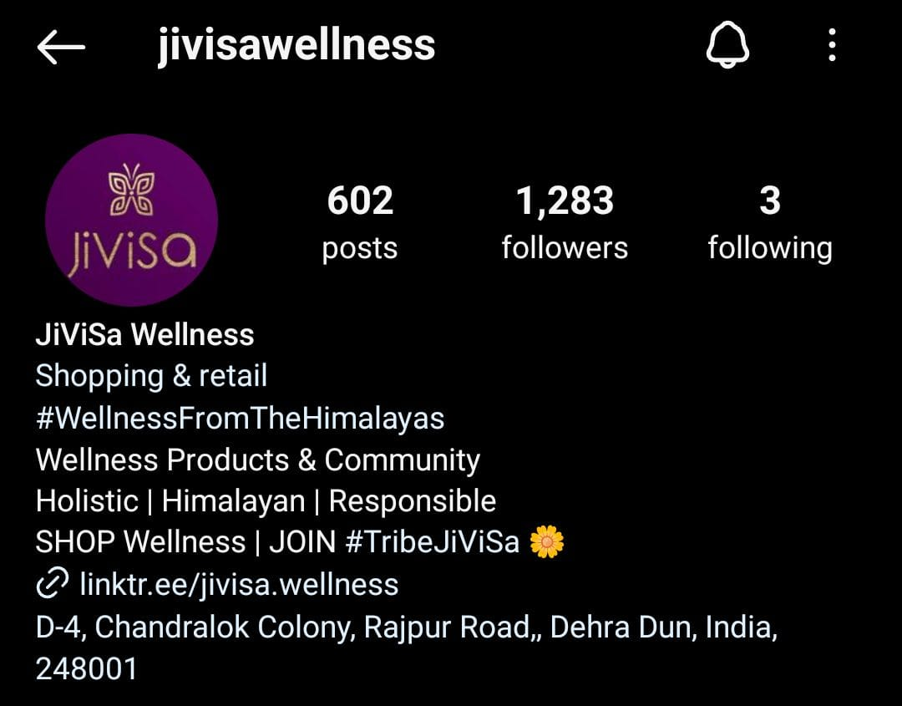

Their Session visits and Sales increases as of Shopify Data:

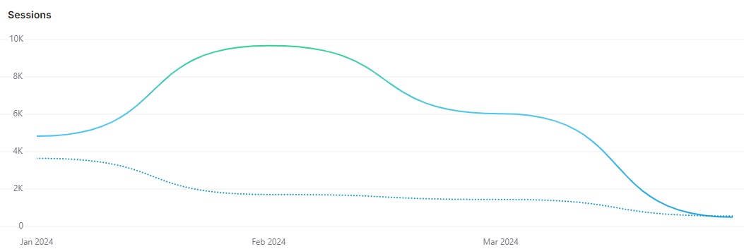

At the Highest we can see that In Feb 2024 compared to Feb 2023 their was a increment in visits with 465% and even a small percentage of conversion of these visits would result and in great sales and it did

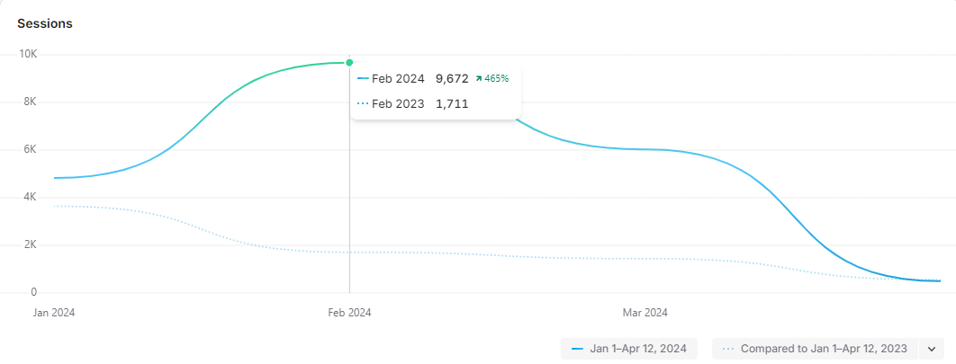

The total session Visits this year is:

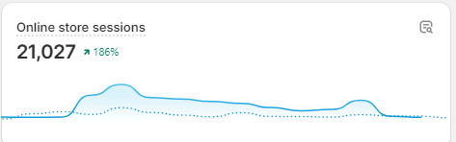

So we can clearly see that since the Live session had started we can see a significant increase in Visits to Website and also the sales

Not just in Terms of performance in sales or Footfall in website their contant creation has also been top Tier since this year especially due to these Live sessions with Influencers as we can see in their instagram

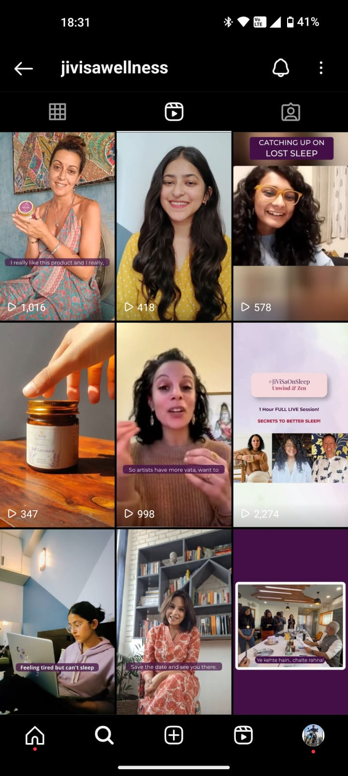

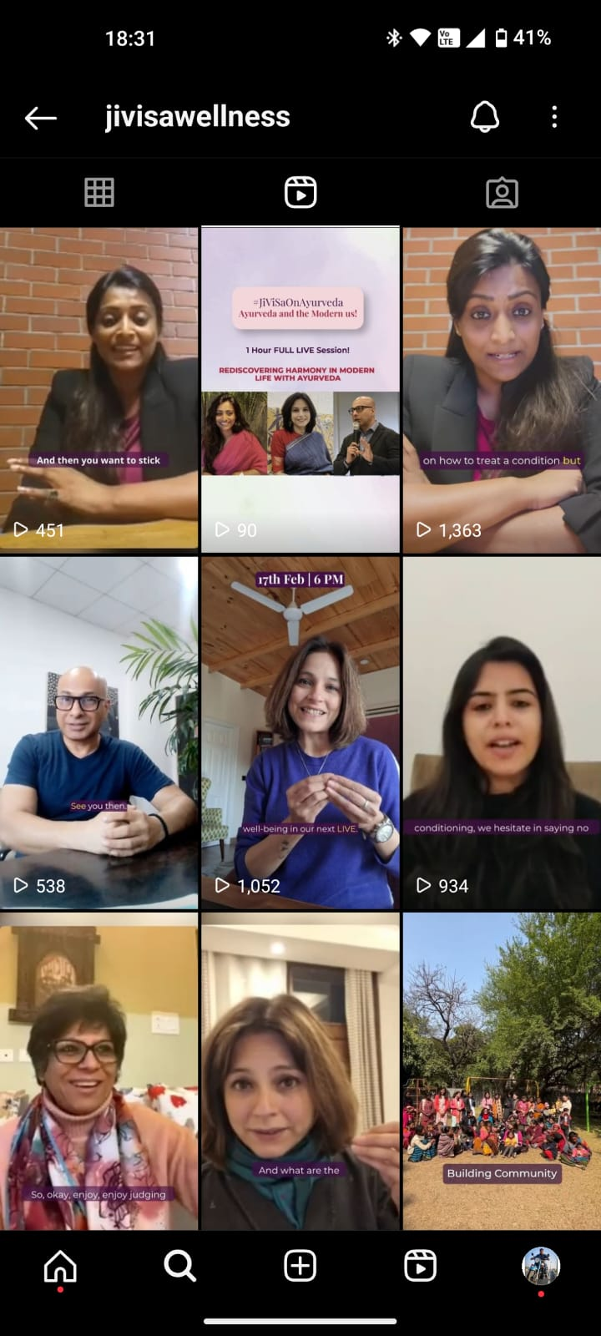

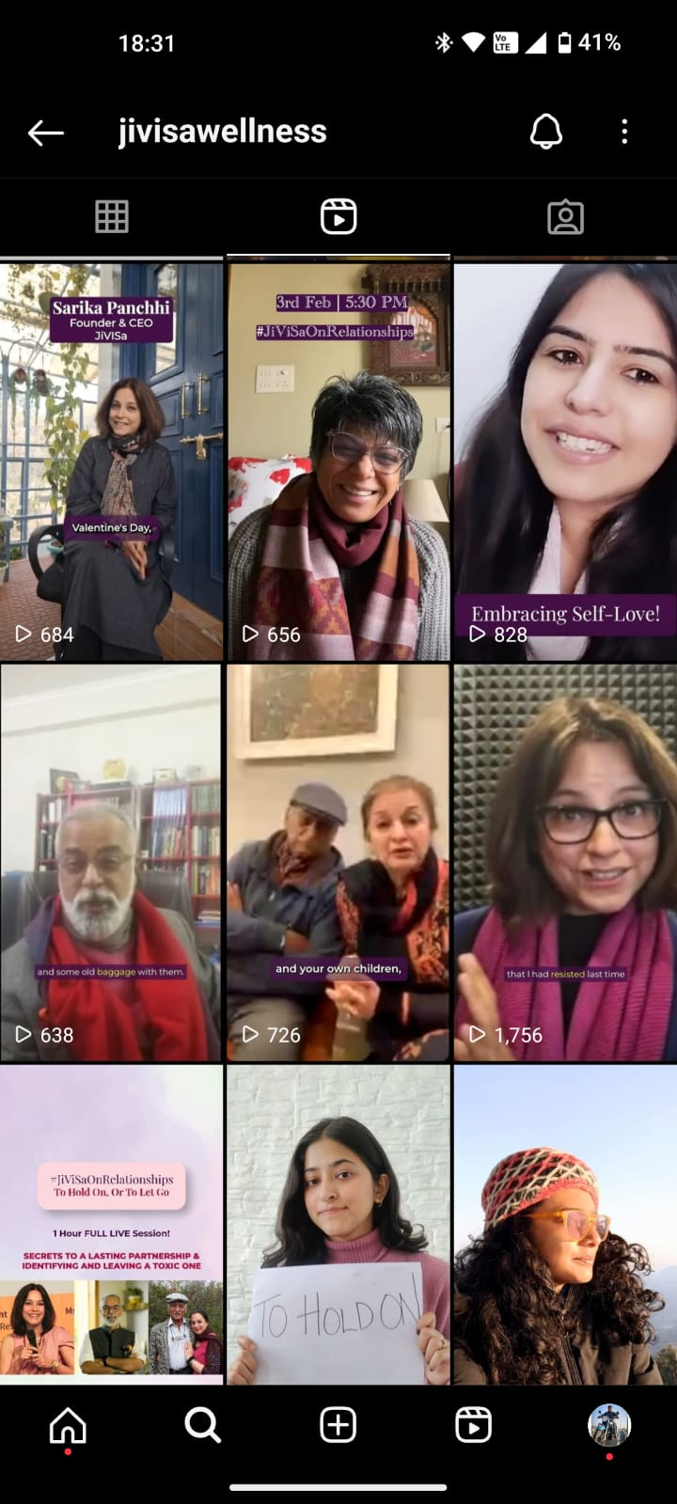



# Influencers:

All of these content shown above were Created with collaboration to those Live Sessions and all these People involved are influencers and have significant impact of their part of the society

Notable Influencers are:

Vineet Panchchi

Tejasvi Singh ( actress) (Kafas SonyLiv)

Niti Gupta ( psychologist)

Manisha Dahad ( transformational influencer)

Zarine Bath (women Entrepreneur)

Damini (psychologist)

Vaidyashikha Prakash ( Ayurvedic Physician)

All of them have had significant effect of their respective Lives sessions with Jivisa and more over they helped Jivisa grow not just in business but also as an ideological perspective.

# Conclusion:

In conclusion, the strategic utilization of influencers has had a significant impact on Jivisa, contributing to its growth and success in the competitive landscape of luxury Ayurvedic products. By partnering with influencers who authentically align with its brand values and target demographic, Jivisa has been able to leverage the power of authentic engagement and storytelling to connect with consumers on a deeper level.

Through live sessions on Instagram, influencers have served as powerful advocates for Jivisa's products, showcasing their features, benefits, and usage tips in real-time. These interactive sessions foster a sense of community and connection with viewers, driving engagement and brand affinity.

Additionally, the repurposing of live session content into reels has extended the reach of Jivisa's influencer marketing efforts, capturing the attention of a wider audience and driving traffic to the brand's Instagram profile and website. This seamless integration between influencer content and brand channels has created a cohesive brand experience for consumers, driving brand visibility and engagement.

Most importantly, the impact of influencers on Jivisa's sales performance cannot be overstated. Through their authentic endorsements and engaging storytelling, influencers have served as powerful drivers of website traffic and conversion rates. The social proof provided by influencers' content has instilled trust and credibility with consumers, prompting them to take action and make a purchase.

In summary, influencers have played a pivotal role in elevating Jivisa's brand presence, driving engagement, and ultimately, contributing to its sales growth. Their authentic advocacy and ability to connect with consumers on a personal level have solidified Jivisa's position as a leader in the luxury Ayurvedic market, paving the way for continued success and expansion in the future.